**Internet store “CITRUS”**

1. Определите наиболее актуальные конфигурации для тестирования интернет магазина основываясь на собранной статистике или опыте о наиболее популярных браузерах, девайсах и операционных систем

2. Приготовь тест план для полной регрессии продукта (обязательно в тест плане должны быть таймлайны, тест стратегия, риски и ресурсы)

**TEST PLAN**

* **Documentation about testing**
* **Start and End Testing**
* **Test Strategy**

The testing strategy determines how we test the product.

Step 1 - Collection of information

Step 2 - Information analysis

Step 3 – Making decisions

Step 4 – Presentation

*Test environment:*

|  |  |
| --- | --- |
| Browser: | Chrome, Mozilla Firefox |
| Operation system: | Windows 10, 7, 8 |
| Cross Browsing testing | BrowserStack |
| Android Browser | Chrome, Mozilla Firefox, IE |
| IOS | Safari |

*Tested site functionality:*

* Product catalog
* Users basket
* Registration form
* Login
* Forms send order
* Change language
* **Configurations**

|  |  |
| --- | --- |
| Personal computer: | Windows 10 |
| Display site on mobile devices: | Xiaomi Redmi 5 Android 8.1 |

* **Risks and restrictions**
* Due to limited resources, we can guarantee the correct display of the site only on devices that are listed in the table “Configurations”.
* Staff shortage
* Problems with staff qualifications
* **Test documentations**
* Test plan
* Checklist
* Bug report
* **Timeline testing stages**

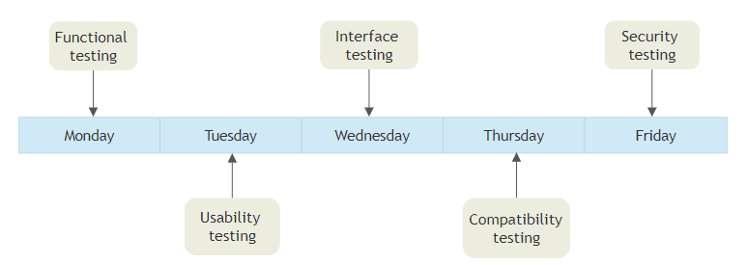

3. Написать и пройти чек-листы для Installation, Usability, GUI, Localization (минимум 10 проверок). Не забудь учесть, что у тебя и мобайл и веб, то-есть 2 чеклиста на каждый вид тестирования, учитывая особенности мобайл и веб

**Check-list GUI**

* Phone screen resolution: 1080×1920, 1920×1080
* Monitor screen resolution 800 x 600, 1024 x 768, 1280 x 1024

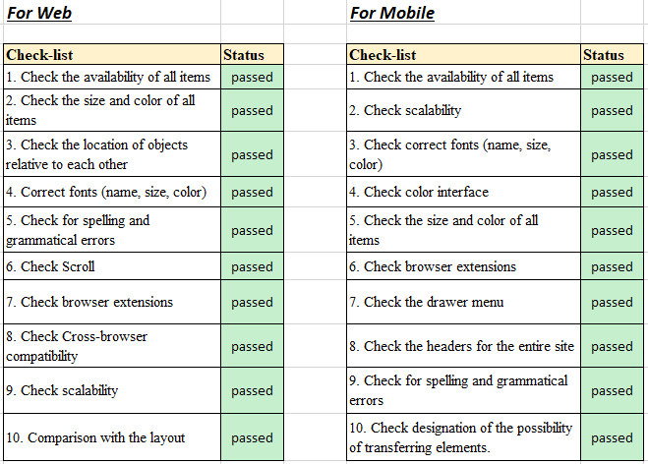

**Check-list Usability**

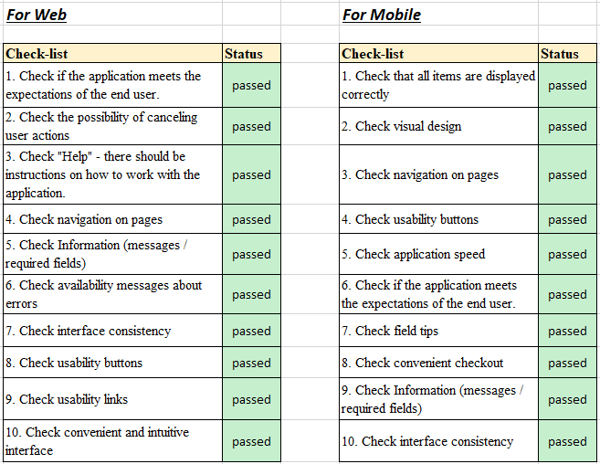

**Check-list Localization**

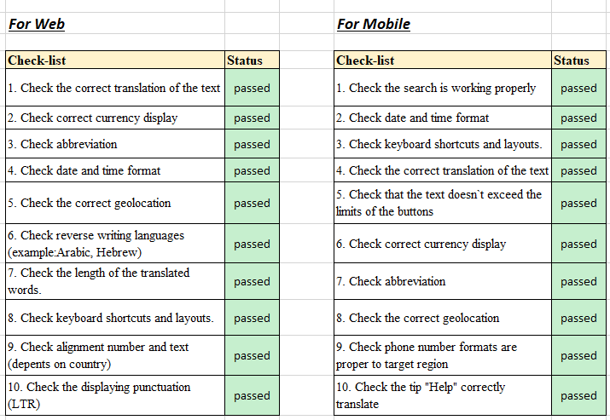

4. Написать и пройти тест кейсы для Smoke testing - минимум по 5 тест кейсов для веб и для мобайл

**Smoke test (web)**

* Ability to View catalog products
* Ability to Search for site
* Ability to Register a user
* Ability to Authorization/Log in
* Possibility to Choose location, city
* Possibility to View basket
* Ability to Choose language on site
* All menu should be by clickable

**Smoke test (mobile)**

* Possibility to Open sandwich menu
* Ability to View catalog products
* Ability to Search for site
* Ability to Register a user
* Ability to Authorization/Log in
* Possibility to Choose location, city
* Possibility to View basket
* Ability to Choose language on site
* All menu should be by clickable
* **Test case (web), registration**

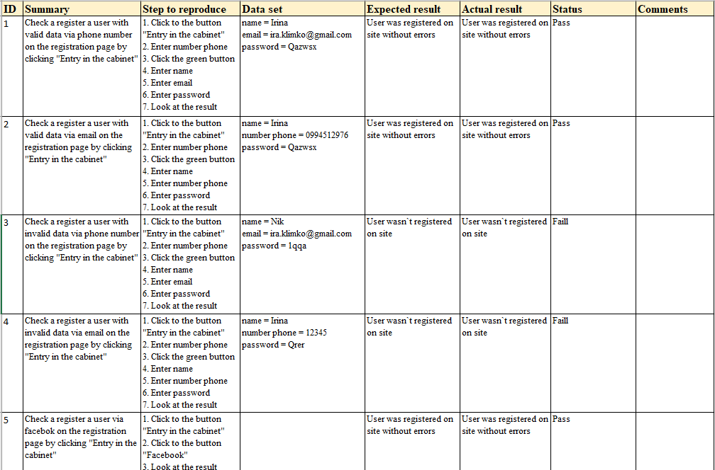

* **Test case (mobile), registration**

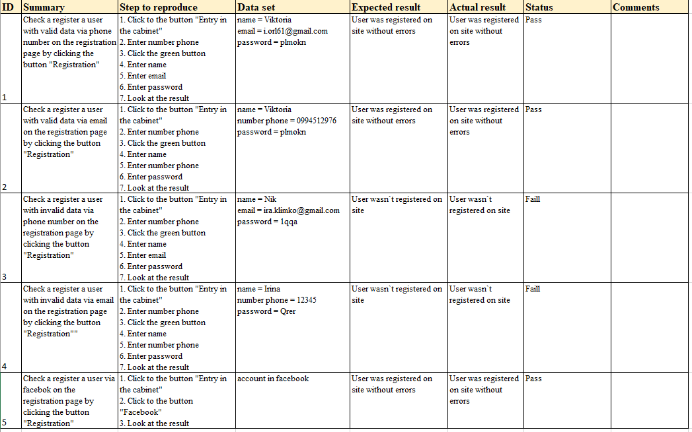

5. Написать и пройти 5-10 тест кейсов для тестирования формы логина используя технику эквивалентных классов и граничных значений. Перед этим написать требования к этой форме логина

**Requirements for form login**

1. Password length: password should be from 6 to 20.
2. Password should be beginning with the upper letter.
3. Password should be contain any symbol: () <>[]:,;@\\"! # $%&'* + -/=? ^_' {} | ~
4. The ability to quickly switch between forms of authorization and registration.
5. Compatibility of authorization forms with password managers of various browsers.
6. Warning massages.
7. Leave the ability to switch between input fields using the «TAB» key and select items using this switch.
8. Email should be accepting upper- and lower-case letters (a-z, A-Z) and numbers from 0 to 9
9. **E-mail with dots (.)**

7.1 Should be accepting id email with one dot

7.2 Email with "..." isn`t accepted

7.3 The leading point in the address is not allowed

**Test Case**

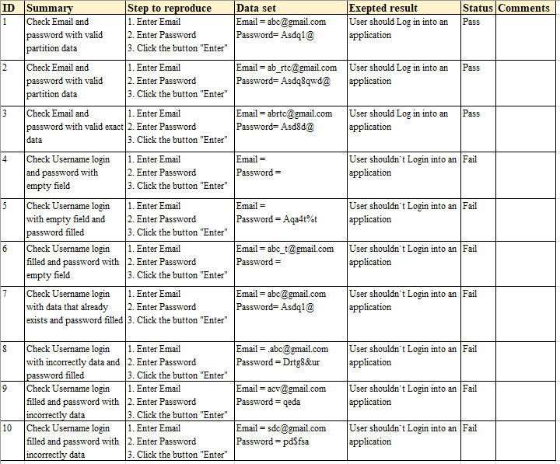

6. Написать и пройти 5-10 юзер сценариев для Critical Path Testing

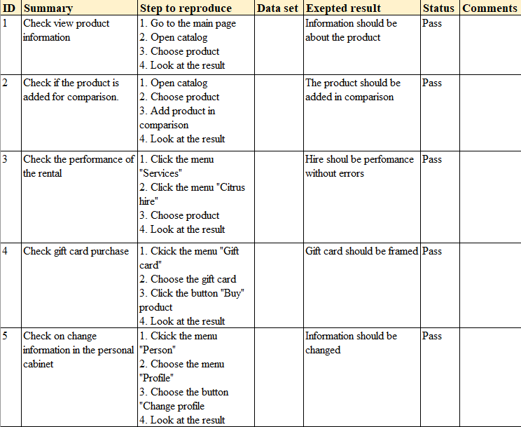

7. Подумать и написать, каким бы путем ты проводила Exploratory Testing и в каких случаях

Using the accumulated experience was the checklist and began to test

Example: Check the use of coupons and promo-codes by placing orders

Use exploratory testing:

* when time is short
* difficulty with requirements
* need to quickly familiarize yourself with the product
* need to provide fast feedback for a new product or new product functionality

8. Завести все найденные баги (миним 5 баг репортов)

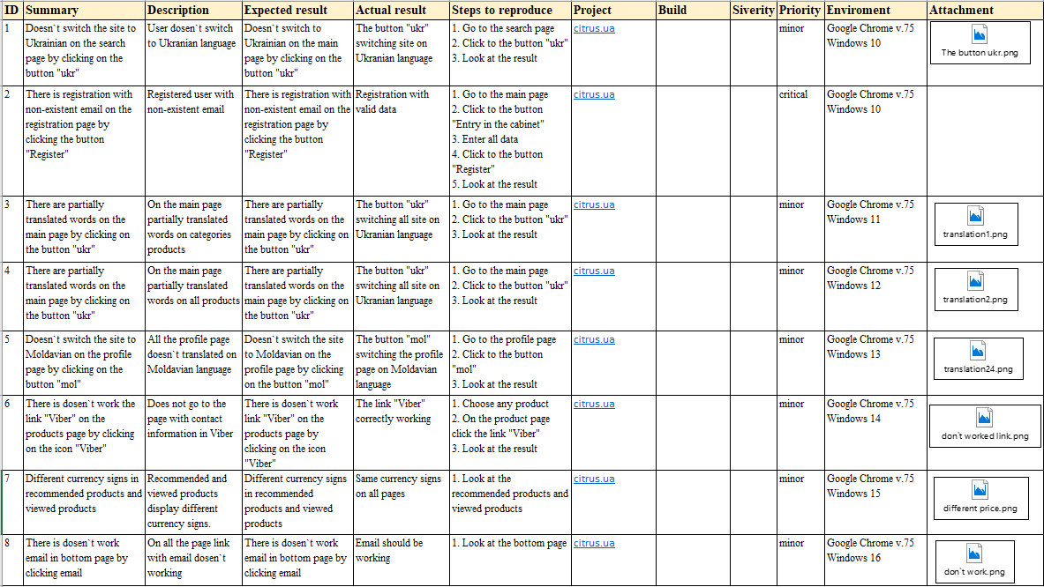

9. По результатам тестирования, написать Test Result Report. Обязательно используем метрики, и если в результате метрик негативный результат - написать твои предложения решения проблемы

As a result of testing on the site, various types of testing were used, and comprehensive product tests were conducted. Found various bugs and flaws.

Brought 7 minor bugs and 1 critical

Compiled test cases for smoke testing, GUI, Usability, Localization.

Wrote the requirements for the login form and passed the test case using the boundary conditions and equivalence classes

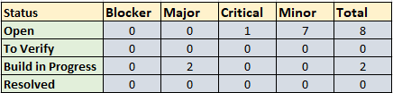

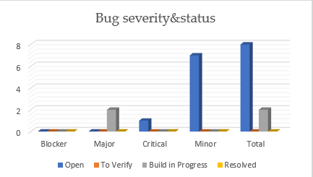

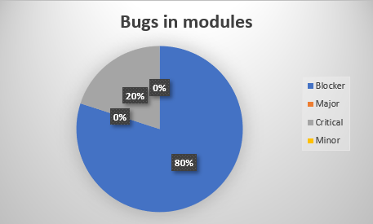

10. Описать, что бы ты покрыла автоматизацией.

Usually, automate regression and this site is no exception. I would cover the regression and the GUI with automation. To make life easier for the tester and leave time for another testing.

Can automate login verification, since login is unchanged.